ASSIGNMENT 2

OSYS1200 – Introduction to Windows Administration

NSCC

Ricardo Oliveira

W0428722

Index

Introduction 2

Question or Research Section 2

Assignment questions 2

Question 1. Here is the first question asked in the assignment 2

Question 2. Here is the second question asked in the assignment 2

Question 3. Here is the third question asked in the assignment 2

Question 4. Here is the forth question asked in the assignment 2

Case Study 2

Here is where I would answer the case study as assigned 2

Screenshots taken during the assignment 2

Screenshot of the sample 2

Screenshot of sample two 3

Script used in assignment 3

Script Sample 1 3

PDF of Change management 4

Attachments in Change management 5

Naming Convention (for full document, see original noted in citation) 5

Works Cited 7

# Introduction

The purpose of this document is to answer any questions asked in the assignment as well as a means to display your change management log and any attachments or screenshots as required.

# Question or Research Section

## Assignment questions TASK 1

Part 2 (submit on Brightspace):

1. For the task configured in Part 1, what are three (3) reasons it important that the task starts only when the computer is idle?

A: There will be no interference caused by the user; It won`t relocate resources in use; Faster execution of the task, as it`s on demand

1. In addition to setting “On a schedule” task weekly, what other time setting options are available?

A: One day; Daily; Monthly.

1. In addition to triggering Begin the task: “on a schedule”, what are the other options available to trigger a task to begin?

A: At log on; At startup; On idle; On an event; At task creation/modification; On connection to user session; On disconnect from user session; On workstation lock; On workstation unlock.

# Case Study

## Here is where I would answer the case study as assigned.

This is where I would place the answer to the case study. I will make sure to answer in a full and complete sentence as professionalism is important.

# Screenshots taken during the assignment

If the assignment requests screenshots this where I might place them.

## Screenshot of the sample

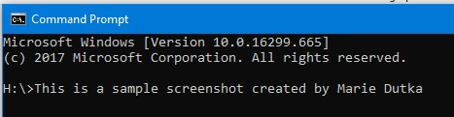

## Screenshot of sample two

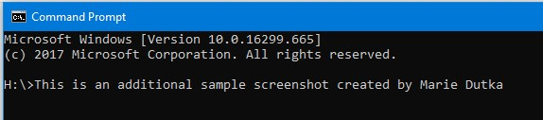

# Script used in assignment

If the assignment requests scripts this where I might place them.

## Script Sample 1

#Created On: Sept 17, 2018

#Author: Sample Student

Sample script to complete a specific task

As required by the assignment

# PDF of Change management

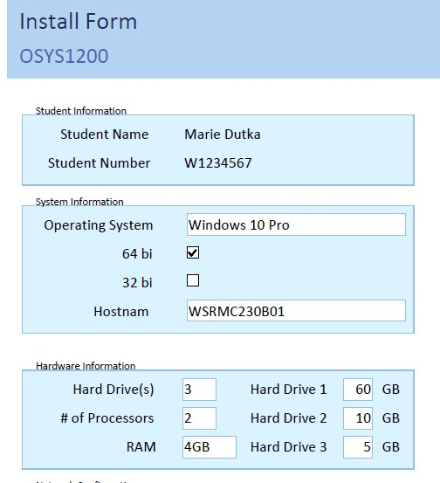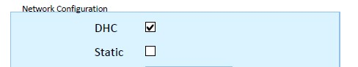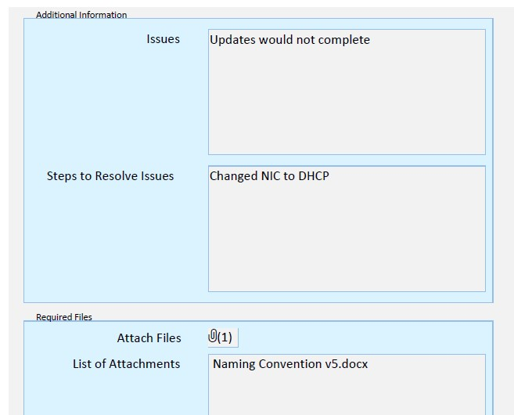

# Attachments in Change management

### Naming Convention (for full document, see original noted in citation)

*Introduction*

Included in this document is the information required for developing conventions and guidelines for Company Inc.

*Virtual Machines*

Virtual Machines will be named using the Course plus the suffix “_**VM**” plus a two (2) digit sequence code.

Example:

OSYS1200_VM01

OSYS1200 + _Virtual Machine + first machine 01

*Workstations and Laptops*

Workstations will be named using the prefix “**WS**” for workstation or “**LT**” for laptop plus RM and room number plus a two (2) digit sequence code.

Example:

WSRM12101

Workstation + Room 121 + workstation 01

*Servers*

Servers will be named using a prefix for the “Server Role” plus RM and room number plus a two (2) digit sequence code.

*Server Roles* o FS = File Server o DB = Database Server o WB = Web Server o VSH = Virtual Server Host o DC = Domain Controller o ES = Email Server

Example:

FSRM12101

File Server + Room 121 + server 01

*Printers*

Printers will be named using the prefix “**PR**” for printer plus RM and room number plus printer model plus a two (2) digit sequence code.

Example:

PRRM112KyC250001

Printer + Room 112 + Kyocera Colour 2500 + printer 01

*Printer Shares*

Printer Shares will be named using the prefix “**PRS**” for printer share plus RM and room number plus a two (2) digit sequence code.

Example:

PRSRM11201

Printer Share + Room 112 + printer 01

*Usernames*

Usernames will be created with the “First Letter” of the employees first name and the “First twelve (12) letters” of the employees last name *Add a two (2) digit sequence code if name already in use. Not to exceed 15 characters. Example:

BSmythe

Bruce + Smythe

# Works Cited

Dutka, M. (2018, 09 17). Naming convention. *Naming convention*. Halifax, NS, Canada: Marie Dutka.

Retrieved from S:\IN Faculty_Student\Marie Dutka\Course Resources

NSCC. (2018, 09 17). *NSCC Brightspace*. Retrieved from NSCC Online Learning: https://nscconline.desire2learn.com/d2l/home